CTM-I Use Case

Internal Switch Maintenance

Version 0.1

Use Case Name | Internal Switch Maintenance
Actor | Market Operations, Operations, App Support
Pre-conditions /Assumptions | User has Browser and is aware of the http path to the application.  User has successfully logged into the CTM-I application.  User has the right role to see the menu options.
Post Conditions | None
Screenshot | 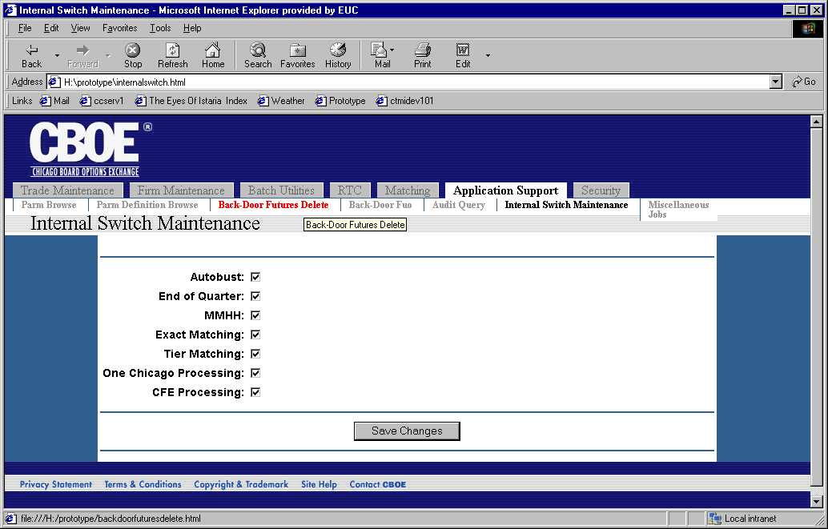
Flow of Events | - User selects “Internal Switch Maintenance” from the menu.  - The Internal Switch Maintenance screen is displayed.  - The following switches are displayed for the user to change.  - Autobust  - End of Quarter  - MMHH  - Exact Matching  - Tier Matching  - One Chicago Processing  - CFE Processing  - The user presses the button “Save Changes” to save any changes made.  - The changes are sent to CTM-R to process.  - The results of the CTM-R processing are displayed on the screen
Alternative Path | None

